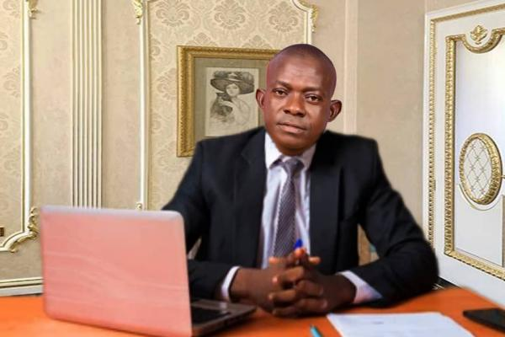**OGBOBUIKE ISAAC EWO**

**fizikaffairs@gmail. Com**

The Executive Director (ED) and Chairman Board of Trustee of **Usamali Ekpeye Brothers’ Foundation (UBEF)**.

**Ogbobuike Isaac Ewo** was born on the 5th of May 1977 at Odiabidi health centre into the family of (Father) Late Ewo Nelson Nyeumu-Nwodhie and (Mother) Mrs. Ewo Dorathy Nelson. He is a native of Okoma 1 Community in Ahoada East Local Government Area, Rivers State of Nigeria.

**Education And Qualification Obtained**

1. He had his First School Living Certificate (FSLC) in the year 1991 at **Universal Primary Education (UPE) Okoma 1.**
2. He had his SSCE Certificate at **Upata 11 Community Secondary Odiabidi** 2003.
3. He studied philosophy and had his Bachelor in Arts (BA) and Letter of Exclusion from National Youth Service Corp (NYSC) in the year 2014 at the Prestigious **University of Port Harcourt Choba.**

**Work Experience**.

1. **ELVINO NIGERIA LTD.** (Shell Club) Industrial & Residential Area Rumubiakani & Rumukurushi, Port Harcourt.

**Position:** Store Keeper 1997-1998

1. **SUPER ENTERPRISE.** Hotel Presidential, Port Harcourt.

**Position:** Room Services & Restaurant Waiter, Bar and Cashier. 1999-2005

1. **HOTEL PRESIDENTIAL, PORT HARCOURT.**

**Position:** General Cashier. 2005-2010

1. **CARLTON CROWN, HOSPITATLITY SERVICES LTD.**

(Hotel and Tourism Management Consultants)

**Position:** Trainer 2005-2013

1. **IVORY HOTEL:** East West Road, Nkpolu Rumuigbo, Port Harcourt

**Position:** Manager 2011-2012

1. **AHOADA EAST LOCAL GOVERNMENT COUNCIL, RIVERS STATE**

**Position:** Personal Assistant to the Caretaker Chairman 2014

**CHRISTIAN LIFE**

**Ogbobuike Isaac Ewo** is member of Anglican Communion church of Nigeria.

He is a member of Diocesan Board of Ahoada Dioceses.

Member, Ahoada Central Archdeaconry Board.

President, Ahoada Central Archdeaconry Christian Men’s Fellowship (ACACMF).

PCC Secretary, Prayer Coordinator, Bible Study Teacher and Welfare Chairman of Anglican Church of the Holy Spirit Edebele Parish Ahoada.

**Ogbobuike Isaac Ewo** had also attended various capacities building training, seminars and workshops.

**SOCIAL LIFE**

**Ogbobuike Isaac Ewo** is member and the presiding Chairman of the **Brother Social Club of Ekpeye.**

**MARRED LIFE:**

**Ogbobuike Isaac Ewo** is married to Mrs. Fidelia Isaac Ewo (Nee Origho Fidelia Vincent) and the marriage has the blessings of God.

**HOBBIES:**

Writing, reading, listing and singing especially hymns and other Christian songs.

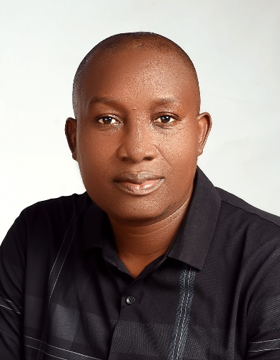

**Secretary BOT and Programme Manager UEBF**

**Mr. Buduzhi Gift Oguzor has expertise in public health nutrition, programming, project management, advocacy, research, agribusiness, agro-processing and innovation. Nutrition Champion and award winner of BNFB Project and CS-SUNN Pooled Fund Project and** **has been part of implementation of high impact nutrition interventions with both government and donor funded programmes in Nigeria. He has used his wealth of professional experience to deepen the use of biofortified foods through product development and in management of malnutrition especially in children and adult in Nigeria. He is the Team Leader of Asa-Uwe Okporowo Ekpeye Farmers’ Co-operative Investment and Credit Society Limited (ASOEK-F-CICS) and CEO BUWA World Life Consult both producers of *Budu Foods* located in Port Harcourt. He served as State Nutrition Officer and currently State Focal Person on Basic Health Care Provision Fund at the Rivers State Primary Health Care Management Board. He is a member of Nutrition Society of Nigeria and National Association of Community Health Practitioners of Nigeria. Currently. At Usamali Ekpeye Brothers Foundation he is serving at various organs to ensure attainment of planned goals and mission.**

**Oguzor, Buduzhi Gift**

Secretary Governing Council Usamali Ekpeye Brothers Foundation/

Secretary Board of Trustee Usamali Ekpeye Brothers Foundation/

Secretary The Brothers Social Club of Ekpeye Ahoada East/West

Programme Manager/Programme Officer Usamali Ekpeye Brothers Foundation

Phone: +2348104037333, +2348132859499

Email: oguzorbuduzhigift@gmail.com, oguzorbg@yahoo.com

Instagram: buduzhioguzor

Facebook.com/buduzhioguzor

Twitter: #buduzhio

Linkedin: buduzhi gift oguzor

Skpe: BUDUZHI Oguzor

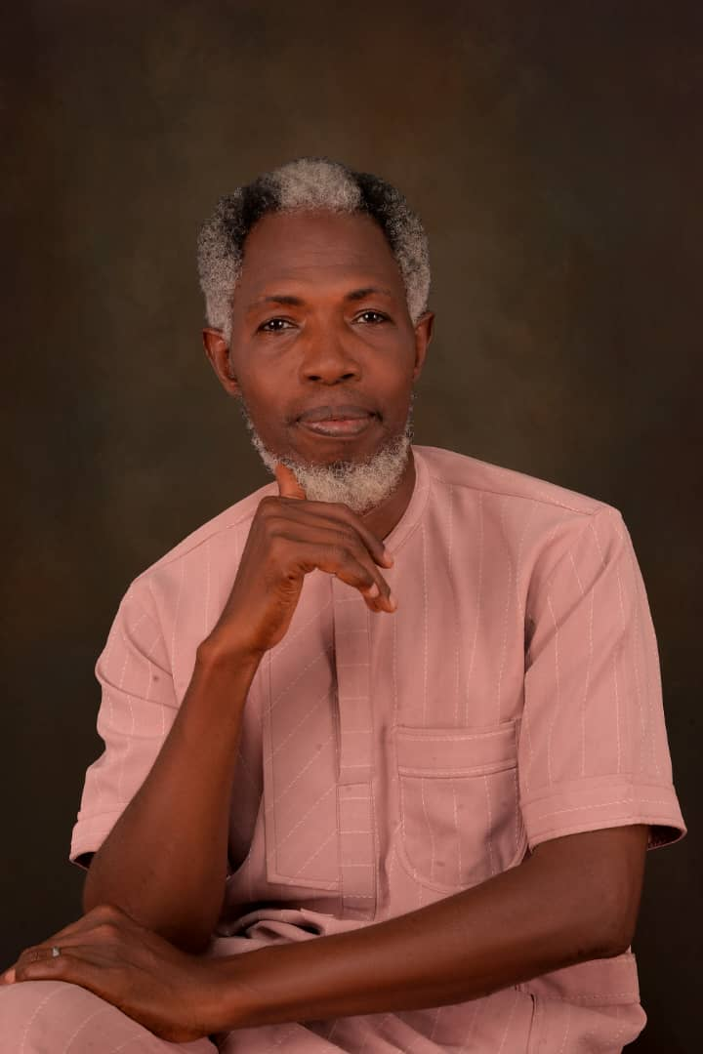

**A BRIEF PROFILE**

**Name: Ordi, Promise Chisa**

**Finance & Admin**

**Nickname:**

**(Ishi-uwor)**

**D.O.B : 28/04/1976**

**Home town:**

**Okporowo-Ekpeye**

**LGA: Ahoada East**

**Marital status:**

**Married.**

**Hobby: Football, writing and traveling.**

**Religion: Christianity**

**Carer: Civil servant**

**Educational background**

**St. Thomas School, Diobu, Port-harcourt. FSLC- 1987**

**Stella Maris College, Port-harcourt. WASC- 1993**

**Rivers State University of science and technology (Now RSU) B.sc - 2007.**

**Organizations and positions:**

**1. Okporowo youth council,.- Secretary**

**2. The Brothers social club - Financial secretary**

**3. Usamali Ekpeye Brothers Foundation - Finance & Admin Mgr.**

**4. Rivers state 2007 Management Alumni Association - President**

**A gentle man, ready to adapt in any situation to serve humanity.**